**Exercise: 10.1**

**1. Fill in the blanks.**

(i) The centre of a circle lies in ____________ of the circle. **(exterior/ interior)**

(ii) A point whose distance from the centre of a circle is greater than its radius lies in __________ of the circle. **(exterior/ interior)**

(iii) The longest chord of a circle is a _____________ of the circle.

(iv) An arc is a ___________ when its ends are the ends of a diameter.

(v) Segment of a circle is the region between an arc and _____________ of the circle.

(vi) A circle divides the plane, on which it lies, in _____________ parts.

**Solution:**

(i) The centre of a circle lies in interior of the circle.

(ii) A point, whose distance from the centre of a circle is greater than its radius lies in exterior of the circle.

(iii) The longest chord of a circle is a diameter of the circle.

(iv) An arc is a semicircle when its ends are the ends of a diameter.

(v) Segment of a circle is the region between an arc and chord of the circle.

(vi) A circle divides the plane, on which it lies, in 3 (three) parts.

**2. Write True or False. Give reasons for your solutions.**

(i) Line segment joining the centre to any point on the circle is a radius of the circle.

(ii) A circle has only a finite number of equal chords.

(iii) If a circle is divided into three equal arcs, each is a major arc.

(iv) A chord of a circle, which is twice as long as its radius, is the diameter of the circle.

(v) Sector is the region between the chord and its corresponding arc.

(vi) A circle is a plane figure.

**Solution:**

(i) True. Any line segment drawn from the centre of the circle to any point on it is the radius of the circle and will be of equal length.

(ii) False. There can be infinite numbers of equal chords in a circle.

(iii) False. For unequal arcs, there can be major and minor arcs. So, equal arcs on a circle cannot be said to be major arcs or minor arcs.

(iv) True. Any chord whose length is twice as long as the radius of the circle always passes through the centre of the circle, and thus, it is known as the diameter of the circle.

(v) False. A sector is a region of a circle between the arc and the two radii of the circle.

(vi) True. A circle is a 2d figure, and it can be drawn on a plane.

**Exercise: 10.2**

**Que 1.** Recall that two circles are congruent if they have the same radii. Prove that equal chords of congruent circles subtend equal angles at their centres.

**Solution:**

To recall, a circle is a collection of points whose every point is equidistant from its centre. So, two circles can be congruent only when the distance of every point of both circles is equal from the centre.

For the second part of the question, it is given that AB = CD, i.e., two equal chords.

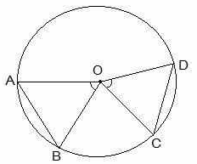Now, it is to be proven that angle AOB is equal to angle COD.

Proof:

Consider the triangles ΔAOB and ΔCOD.

OA = OC and OB = OD (Since they are the radii of the circle.)

AB = CD (As given in the question.)

So, by SSS congruency, ΔAOB ≅ ΔCOD

∴ By CPCT, we have,

∠AOB = ∠COD (Hence, proved).

**Que 2. Prove that if chords of congruent circles subtend equal angles at their centres, then the chords are equal.**

**Solution:**

Consider the following diagram.

Here, it is given that ∠AOB = ∠COD, i.e., they are equal angles.

Now, we will have to prove that the line segments AB and CD are equal, i.e., AB = CD.

Proof:

In triangles AOB and COD,

∠AOB = ∠COD (As given in the question.)

OA = OC and OB = OD (These are the radii of the circle.)

So, by SAS congruency, ΔAOB ≅ ΔCOD

∴ By the rule of CPCT, we have,

AB = CD (Hence, proved.)

**Exercise: 10.3**

**Que 1.** Draw different pairs of circles. How many points does each pair have in common? What is the maximum number of common points?

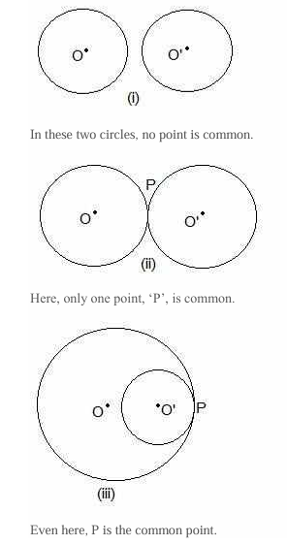**Solution:**

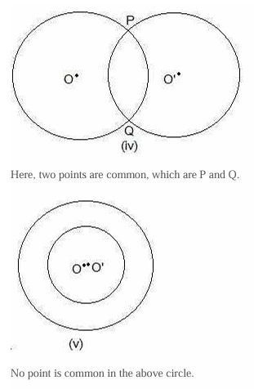

**Que 1. Two circles of radii 5 cm and 3 cm intersect at two points, and the distance between their centres is 4 cm. Find the length of the common chord.**

**Solution:**

**The perpendicular bisector of the common chord passes through the centres of both circles.**

**As the circles intersect at two points, we can construct the above figure.**

**Consider AB as the common chord and O and O’ as the centres of the circles.**

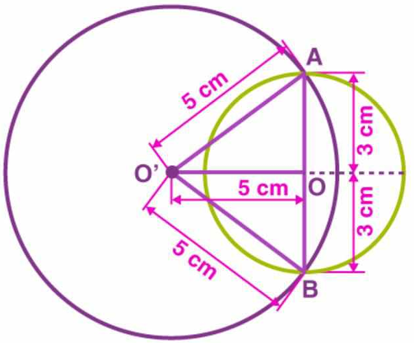**O’A = 5 cm**

**OA = 3 cm**

**OO’ = 4 cm [Distance between centres is 4 cm.]**

**As the radius of the bigger circle is more than the distance between the two centres, we know that the centre of the**

**smaller circle lies inside the bigger circle.**

**The perpendicular bisector of AB is OO’.**

**OA = OB = 3 cm**

**As O is the midpoint of AB**

**AB = 3 cm + 3 cm = 6 cm**

**The length of the common chord is 6 cm.**

**It is clear that the common chord is the diameter of the smaller circle.**

**Que 2. If two equal chords of a circle intersect within the circle, prove that the segments of one chord are equal to corresponding segments of the other chord.**

**Solution:**

**Let AB and CD be two equal cords (i.e., AB = CD). In the above question, it is given that AB and CD intersect at a point, say, E.**

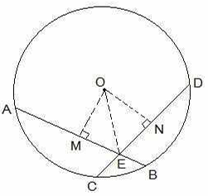**It is now to be proven that the line segments AE = DE and CE = BE**

**Construction Steps**

**Step 1: From the centre of the circle, draw a perpendicular to AB, i.e., OM ⊥ AB.**

**Step 2: Similarly, draw ON ⊥ CD.**

**Step 3: Join OE.**

**Proof:**

**From the diagram, it is seen that OM bisects AB, and so OM ⊥ AB**

**Similarly, ON bisects CD, and so ON ⊥ CD.**

**It is known that AB = CD. So,**

**AM = ND — (i)**

**and MB = CN — (ii)**

**Now, triangles ΔOME and ΔONE are similar by RHS congruency, since**

**∠OME = ∠ONE (They are perpendiculars.)**

**OE = OE (It is the common side.)**

**OM = ON (AB and CD are equal, and so they are equidistant from the centre.)**

**∴ ΔOME ≅ ΔONE**

**ME = EN (by CPCT) — (iii)**

**Now, from equations (i) and (ii), we get**

**AM+ME = ND+EN**

**So, AE = ED**

**Now from equations (ii) and (iii), we get**

**MB-ME = CN-EN**

**So, EB = CE (Hence, proved)**

**Que 3. If two equal chords of a circle intersect within the circle, prove that the line joining the point of intersection to**

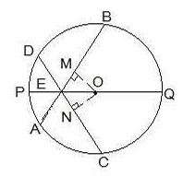**the centre makes equal angles with the chords.**

**Solution:**

**From the question, we know the following:**

**(i) AB and CD are 2 chords which are intersecting at point E.**

**(ii) PQ is the diameter of the circle.**

**(iii) AB = CD.**

**Now, we will have to prove that ∠BEQ = ∠CEQ**

**For this, the following construction has to be done.**

**Construction:**

**Draw two perpendiculars are drawn as OM ⊥ AB and ON ⊥ D. Now, join OE. The constructed diagram will look as follows:**

**Now, consider the triangles ΔOEM and ΔOEN. Here,**

**(i) OM = ON [The equal chords are always equidistant from the centre.]**

**(ii) OE = OE [It is the common side.]**

**(iii) ∠OME = ∠ONE [These are the perpendiculars.]**

**So, by RHS congruency criterion, ΔOEM ≅ ΔOEN.**

**Hence, by the CPCT rule, ∠MEO = ∠NEO**

**∴ ∠BEQ = ∠CEQ (Hence, proved)**

Que 4. If a line intersects two concentric circles (circles with the same centre) with centre O at A, B, C and D, prove that AB = CD (see Fig. 10.25).

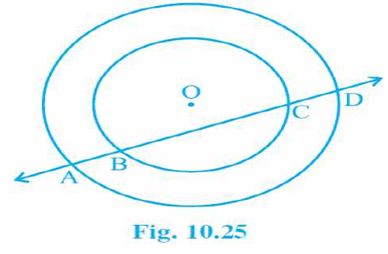

**Solution:** The given image is as follows:

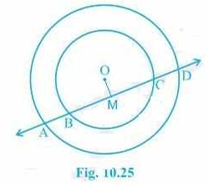

**First, draw a line segment from O to AD, such that OM ⊥ AD.**

**So, now OM is bisecting AD since OM ⊥ AD.**

**Therefore, AM = MD — (i)**

**Also, since OM ⊥ BC, OM bisects BC.**

**Therefore, BM = MC — (ii)**

**From equation (i) and equation (ii),**

**AM-BM = MD-MC**

**∴ AB = CD**

**Que 5.** Three girls, Reshma, Salma and Mandip, are playing a game by standing on a circle of radius 5m drawn in a park. Reshma throws a ball to Salma, Salma to Mandip, and Mandip to Reshma. If the distance between Reshma and Salma and between Salma and Mandip is 6m each, what is the distance between Reshma and Mandip?

**Solution:**

**Let the positions of Reshma, Salma and Mandip be represented as A, B and C, respectively.**

**From the question, we know that AB = BC = 6cm**

**So, the radius of the circle, i.e., OA = 5cm**

**Now, draw a perpendicular BM ⊥ AC.**

**Since AB = BC, ABC can be considered an isosceles triangle. M is the mid-point of AC. BM is the perpendicular bisector of AC, and thus it passes through the centre of the circle.**

**Now,**

**let AM = y and OM = x**

**So, BM will be = (5-x).**

**By applying the Pythagorean theorem in ΔOAM, we get**

**OA2 = OM2 +AM2**

**⇒ 52 = x2 +y2 — (i)**

**Again, by applying the Pythagorean theorem in ΔAMB,**

**AB2 = BM2 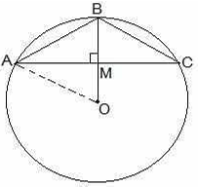+AM2**

**⇒ 62 = (5-x)2+y2 — (ii)**

**Subtracting equation (i) from equation (ii), we get**

**36-25 = (5-x)2 +y2 -x2-y2**

**Now, solving this equation, we get the value of x as**

**x = 7/5**

**Substituting the value of x in equation (i), we get**

**y2 +(49/25) = 25**

**⇒ y2 = 25 – (49/25)**

**Solving it, we get the value of y as**

**y = 24/5**

**Thus,**

**AC = 2×AM = 2×y = 2×(24/5) m**

**AC = 9.6 m**

**So, the distance between Reshma and Mandip is 9.6 m.**

**Que 6. A circular park of radius 20m is situated in a colony. Three boys, Ankur, Syed and David, are sitting at equal distances on its boundary, each having a toy telephone in his hands to talk to each other. Find the length of the string of each phone.**

**Solution:** First, draw a diagram according to the given statements. The diagram will look as follows:

**Here, the positions of Ankur, Syed and David are represented as A, B and C, respectively. Since they are sitting at**

**equal distances, the triangle ABC will form an equilateral triangle.**

**AD ⊥ BC is drawn. Now, AD is the median of ΔABC, and it passes through the centre O.**

**Also, O is the centroid of the ΔABC. OA is the radius of the triangle.**

**OA = 2/3 AD**

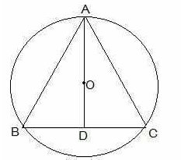**Let the side of a triangle a metres, then BD = a/2 m.**

**Applying Pythagoras’ theorem in ΔABD,**

**AB2 = BD2+AD2**

**⇒ AD2 = AB2 -BD2**

**⇒ AD2 = a2 -(a/2)2**

**⇒ AD2 = 3a2/4**

**⇒ AD = √3a/2**

**OA = 2/3 AD**

**20 m = 2/3 × √3a/2**

**a = 20√3 m**

**So, the length of the string of the toy is 20√3 m.**

**Que 6. ABCD is a cyclic quadrilateral whose diagonals intersect at point E. If ∠ DBC = 70°, ∠ BAC is 30°, find ∠**

**BCD. Further, if AB = BC, find ∠ ECD.**

**Solution: 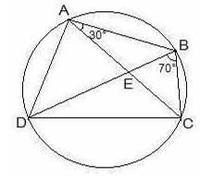Consider the following diagram.**

**Consider the chord CD.**

**We know that angles in the same segment are equal.**

**So, ∠ CBD = ∠ CAD**

**∴ ∠ CAD = 70°**

**Now, ∠ BAD will be equal to the sum of angles BAC and CAD.**

**So, ∠ BAD = ∠ BAC+∠ CAD= 30°+70°**

**∴ ∠ BAD = 100°**

**We know that the opposite angles of a cyclic quadrilateral sum up to 180 degrees.**

**So,**

**∠ BCD+∠ BAD = 180°**

**It is known that ∠ BAD = 100°**

**So, ∠ BCD = 80°**

**Now, consider the ΔABC.**

**Here, it is given that AB = BC**

**Also, ∠ BCA = ∠ CAB (They are the angles opposite to equal sides of a triangle)**

**∠ BCA = 30°**

**also, ∠ BCD = 80°**

**∠ BCA +∠ ACD = 80°**

**Thus, ∠ ACD = 50° and ∠ ECD = 50°**

**Que 7. If diagonals of a cyclic quadrilateral are diameters of the circle through the vertices of the quadrilateral, prove that it is a rectangle.**

**Solution:**

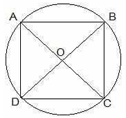**Draw a cyclic quadrilateral ABCD inside a circle with centre O, such that its diagonal AC and BD are two diameters of the circle.**

**We know that the angles in the semi-circle are equal.**

**So, ∠ ABC = ∠ BCD = ∠ CDA = ∠ DAB = 90°**

**So, as each internal angle is 90°, it can be said that the quadrilateral ABCD is a rectangle.**

Que 8. If the non-parallel sides of a trapezium are equal, prove that it is cyclic.

Solution:

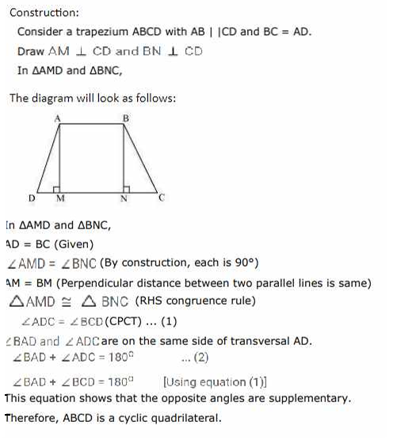

Que 9. Two circles intersect at two points, B and C. Through B, two line segments ABD and PBQ are drawn to intersect the circles at A, D and P, Q, respectively (see Fig. 10.40). Prove that ∠ ACP = ∠ QCD.

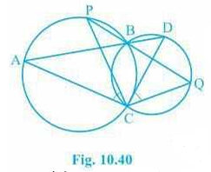

**Solution:**

**Join the chords AP and DQ.**

**For chord AP, we know that angles in the same segment are equal.**

**So, ∠ PBA = ∠ ACP — (i)**

**Similarly, for chord DQ,**

**∠ DBQ = ∠ QCD — (ii)**

**It is known that ABD and PBQ are two line segments which are intersecting at B.**

**At B, the vertically opposite angles will be equal.**

**∴ ∠ PBA = ∠ DBQ — (iii)**

**From equation (i), equation (ii) and equation (iii), we get**

**∠ ACP = ∠ QCD**

**Que 10. If circles are drawn taking two sides of a triangle as diameters, prove that the point of intersection of these**

**circles lies on the third side.**

**Solution:**

**First, draw a triangle ABC and then two circles having diameters of AB and AC, respectively.**

**We will have to now prove that D lies on BC and BDC is a straight line.**

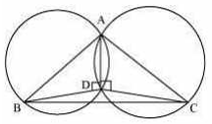

**Proof:**

**We know that angles in the semi-circle are equal.**

**So, ∠ ADB = ∠ ADC = 90°**

**Hence, ∠ ADB+∠ ADC = 180°**

**∴ ∠ BDC is a straight line.**

**So, it can be said that D lies on the line BC.**

**Que 11. ABC and ADC are two right triangles with common hypotenuse AC. Prove that ∠ CAD = ∠CBD.**

**Solution:**

**We know that AC is the common hypotenuse and ∠ B = ∠ D = 90°.**

**Now, it has to be proven that ∠ CAD = ∠ CBD**

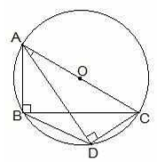

**Since ∠ ABC and ∠ ADC are 90°, it can be said that they lie in a semi-circle.**

**So, triangles ABC and ADC are in the semi-circle, and the points A, B, C and D are concyclic.**

**Hence, CD is the chord of the circle with centre O.**

**We know that the angles which are in the same segment of the circle are equal.**

**∴ ∠ CAD = ∠ CBD**